## lvm setup linux

## What is LVM?

LVM is a tool for logical volume management which includes allocating disks, striping, mirroring and resizing logical volumes.

With LVM, a hard drive or set of hard drives is allocated to one or more physical volumes. LVM physical volumes can be placed on other block devices which might span two or more disks.

The physical volumes are combined into logical volumes, with the exception of the /boot partition. The /boot partition cannot be on a logical volume group because the boot loader cannot read it. If the root (/) partition is on a logical volume, create a separate /boot partition which is not a part of a volume group.

Since a physical volume cannot span over multiple drives, to span over more than one drive, create one or more physical volumes per drive.

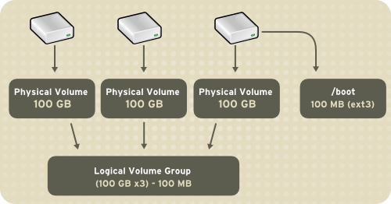

**Figure 11.1. Logical Volumes**

The volume groups can be divided into logical volumes, which are assigned mount points, such as /home and / and file system types, such as ext2 or ext3. When "partitions" reach their full capacity, free space from the volume group can be added to the logical volume to increase the size of the partition. When a new hard drive is added to the system, it can be added to the volume group, and partitions that are logical volumes can be increased in size.

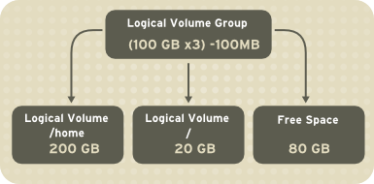

**Figure 11.2. Logical Volumes**

On the other hand, if a system is partitioned with the ext3 file system, the hard drive is divided into partitions of defined sizes. If a partition becomes full, it is not easy to expand the size of the partition. Even if the partition is moved to another hard drive, the original hard drive space has to be reallocated as a different partition or not used.

To learn how to configure LVM during the installation process, refer to [Section 11.2, “LVM Configuration”](https://access.redhat.com/documentation/en-us/red_hat_enterprise_linux/5/html/deployment_guide/s-lvm-config).

### 11.1.1. What is LVM2?

LVM version 2, or LVM2, is the default for Red Hat Enterprise Linux 5, which uses the device mapper driver contained in the 2.6 kernel. LVM2 can be upgraded from versions of Red Hat Enterprise Linux running the 2.4 kernel.

**LVM CONFIGURATION**

LVM can be configured during the graphical installation process, the text-based installation process, or during a kickstart installation. You can use the system-config-lvm utility to create your own LVM configuration post-installation. The next two sections focus on using **Disk Druid** during installation to complete this task. The third section introduces the LVM utility (system-config-lvm) which allows you to manage your LVM volumes in X windows or graphically.

Read [Section 11.1, “What is LVM?”](https://access.redhat.com/documentation/en-us/red_hat_enterprise_linux/5/html/deployment_guide/ch-lvm#s1-lvm-intro-whatis) first to learn about LVM. An overview of the steps required to configure LVM include:

* Creating *physical volumes* from the hard drives.
* Creating *volume groups* from the physical volumes.
* Creating *logical volumes* from the volume groups and assign the logical volumes mount points.

Two 9.1 GB SCSI drives (/dev/sda and /dev/sdb) are used in the following examples. They detail how to create a simple configuration using a single LVM volume group with associated logical volumes during installation.

**AUTOMATIC PARTITIONING**

On the **Disk Partitioning Setup** screen, select **Remove linux partitions on selected drives and create default layout** from the pulldown list.

For Red Hat Enterprise Linux, LVM is the default method for disk partitioning. If you do not wish to have LVM implemented, or if you require RAID partitioning, manual disk partitioning through **Disk Druid** is required.

The following properties make up the automatically created configuration:

* The /boot partition resides on its own non-LVM partition. In the following example, it is the first partition on the first drive (/dev/sda1). Bootable partitions *cannot* reside on LVM logical volumes.
* A single LVM volume group (VolGroup00) is created, which spans all selected drives and all remaining space available. In the following example, the remainder of the first drive (/dev/sda2), and the entire second drive (/dev/sdb1) are allocated to the volume group.
* Two LVM logical volumes (LogVol00 and LogVol01) are created from the newly created spanned volume group. In the following example, the recommended swap space is automatically calculated and assigned to LogVol01, and the remainder is allocated to the root file system, LogVol00.

[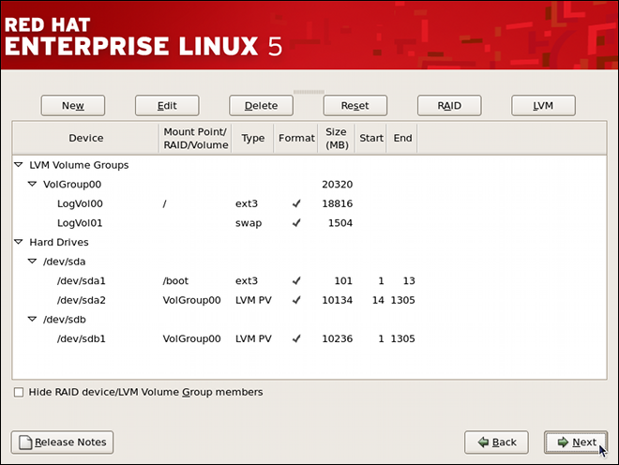](https://access.redhat.com/webassets/avalon/d/Red_Hat_Enterprise_Linux-5-Deployment_Guide-en-US/images/b6c5ad58dcb0db97ee65c0ada77eba79/lvm-auto-config.png)

**Figure 11.3. Automatic LVM Configuration With Two SCSI Drives**

**Note**

If enabling quotas are of interest to you, it may be best to modify the automatic configuration to include other mount points, such as /home or /var, so that each file system has its own independent quota configuration limits.

In most cases, the default automatic LVM partitioning is sufficient, but advanced implementations could warrant modification or manual configuration of the partition tables.

**Note**

If you anticipate future memory upgrades, leaving some free space in the volume group would allow for easy future expansion of the swap space logical volume on the system; in which case, the automatic LVM configuration should be modified to leave available space for future growth.

# MANUAL LVM PARTITIONING

The following section explains how to manually configure LVM for Red Hat Enterprise Linux. Because there are numerous ways to manually configure a system with LVM, the following example is similar to the default configuration done in [Section 11.3, “Automatic Partitioning”](https://access.redhat.com/documentation/en-us/red_hat_enterprise_linux/5/html/deployment_guide/s1-lvm-diskdruid-auto).

On the **Disk Partitioning Setup** screen, select **Create custom layout** from the pulldown list and click the **Next** button in the bottom right corner of the screen.

### 11.4.1. Creating the /boot Partition

In a typical situation, the disk drives are new, or formatted clean. The following figure, [Figure 11.4, “Two Blank Drives, Ready for Configuration”](https://access.redhat.com/documentation/en-us/red_hat_enterprise_linux/5/html/deployment_guide/s1-lvm-diskdruid-manual#fig-lvm-manual-free), shows both drives as raw devices with no partitioning configured.

[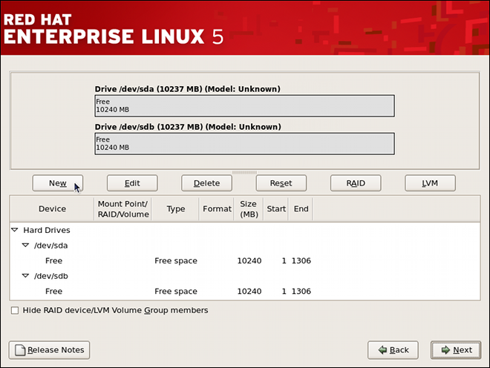](https://access.redhat.com/webassets/avalon/d/Red_Hat_Enterprise_Linux-5-Deployment_Guide-en-US/images/8b48d5b98ffb98b7d7cfb414f952e5a8/lvm-manual-free.png)

**Figure 11.4. Two Blank Drives, Ready for Configuration**

**Warning**

The /boot partition cannot reside on an LVM volume because the GRUB boot loader cannot read it.

1. Select **New**.
2. Select **/boot** from the **Mount Point** pulldown menu.
3. Select **ext3** from the **File System Type** pulldown menu.
4. Select only the **sda** checkbox from the **Allowable Drives** area.
5. Leave **100** (the default) in the **Size (MB)** menu.
6. Leave the **Fixed size** (the default) radio button selected in the **Additional Size Options** area.
7. Select **Force to be a primary partition** to make the partition be a primary partition. A primary partition is one of the first four partitions on the hard drive. If unselected, the partition is created as a logical partition. If other operating systems are already on the system, unselecting this option should be considered. For more information on primary versus logical/extended partitions, refer to the appendix section of the Red Hat Enterprise Linux Installation Guide.

Refer to [Figure 11.5, “Creation of the Boot Partition”](https://access.redhat.com/documentation/en-us/red_hat_enterprise_linux/5/html/deployment_guide/s1-lvm-diskdruid-manual#fig-lvm-manual-boot) to verify your inputted values:

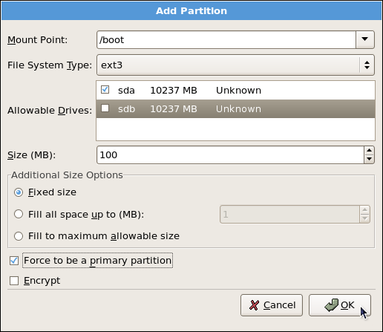

**Figure 11.5. Creation of the Boot Partition**

Click **OK** to return to the main screen. The following figure displays the boot partition correctly set:

[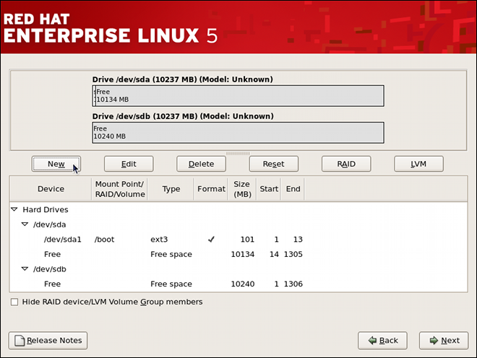](https://access.redhat.com/webassets/avalon/d/Red_Hat_Enterprise_Linux-5-Deployment_Guide-en-US/images/ffb970905312d39f91ec7ef9a0464248/lvm-manual-postboot.png)

**Figure 11.6. The /boot Partition Displayed**

**CREATING THE LVM PHYSICAL VOLUMES**

Once the boot partition is created, the remainder of all disk space can be allocated to LVM partitions. The first step in creating a successful LVM implementation is the creation of the physical volume(s).

1. Select **New**.
2. Select **physical volume (LVM)** from the **File System Type** pulldown menu as shown in [Figure 11.7, “Creating a Physical Volume”](https://access.redhat.com/documentation/en-us/red_hat_enterprise_linux/5/html/deployment_guide/s2-lvm-diskdruid-manual-pv#fig-lvm-manual-pv01).

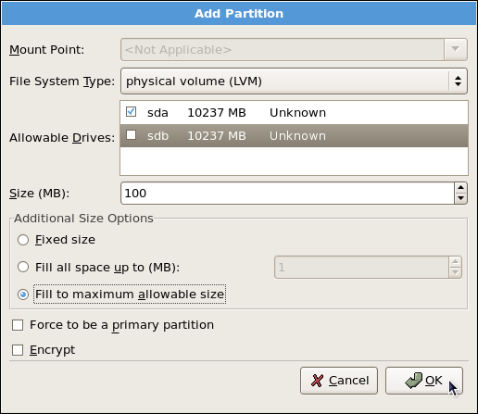

**Figure 11.7. Creating a Physical Volume**

1. You cannot enter a mount point yet (you can once you have created all your physical volumes and then all volume groups).
2. A physical volume must be constrained to one drive. For **Allowable Drives**, select the drive on which the physical volume are created. If you have multiple drives, all drives are selected, and you must deselect all but one drive.
3. Enter the size that you want the physical volume to be.
4. Select **Fixed size** to make the physical volume the specified size, select **Fill all space up to (MB)** and enter a size in MBs to give range for the physical volume size, or select **Fill to maximum allowable size** to make it grow to fill all available space on the hard disk. If you make more than one growable, they share the available free space on the disk.
5. Select **Force to be a primary partition** if you want the partition to be a primary partition.
6. Click **OK** to return to the main screen.

Repeat these steps to create as many physical volumes as needed for your LVM setup. For example, if you want the volume group to span over more than one drive, create a physical volume on each of the drives. The following figure shows both drives completed after the repeated process:

[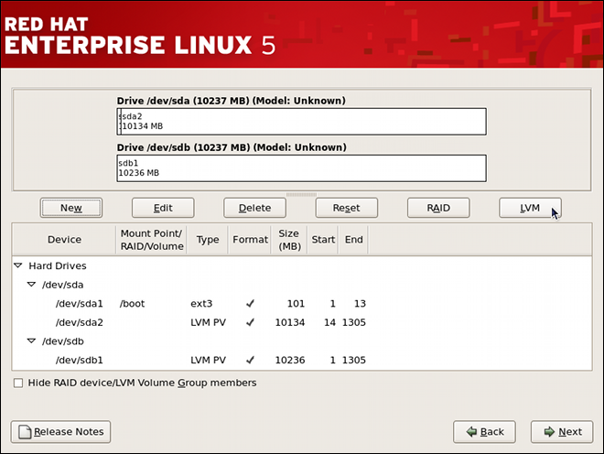](https://access.redhat.com/webassets/avalon/d/Red_Hat_Enterprise_Linux-5-Deployment_Guide-en-US/images/5460e9776987cbf65a7c5710d6082953/lvm-manual-pvdone.png)

**Figure 11.8. Two Physical Volumes Created**

**CREATING THE LVM VOLUME GROUPS**

Once all the physical volumes are created, the volume groups can be created:

1. Click the **LVM** button to collect the physical volumes into volume groups. A volume group is basically a collection of physical volumes. You can have multiple logical volumes, but a physical volume can only be in one volume group.

**Note**

There is overhead disk space reserved in the volume group. The volume group size is slightly less than the total of physical volume sizes.

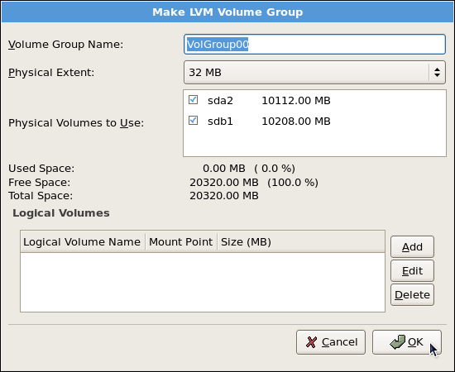

**Figure 11.9. Creating an LVM Volume Group**

1. Change the **Volume Group Name** if desired.
2. All logical volumes inside the volume group must be allocated in *physical extent (PE)* units. A physical extent is an allocation unit for data.
3. Select which physical volumes to use for the volume group.
4. **CREATING THE LVM LOGICAL VOLUMES**
5. Create logical volumes with mount points such as /, /home, and swap space. Remember that /boot cannot be a logical volume. To add a logical volume, click the **Add** button in the **Logical Volumes** section. A dialog window as shown in [Figure 11.10, “Creating a Logical Volume”](https://access.redhat.com/documentation/en-us/red_hat_enterprise_linux/5/html/deployment_guide/s2-lvm-diskdruid-manual-lv#fig-lvm-manual-lv) appears.
6. 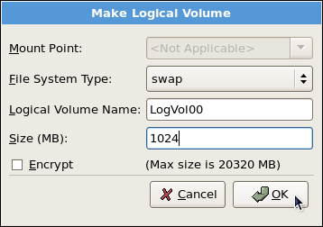
7. **Figure 11.10. Creating a Logical Volume**
8. Repeat these steps for each volume group you want to create.
9. **Note**
10. You may want to leave some free space in the volume group so you can expand the logical volumes later. The default automatic configuration does not do this, but this manual configuration example does — approximately 1 GB is left as free space for future expansion.
11. 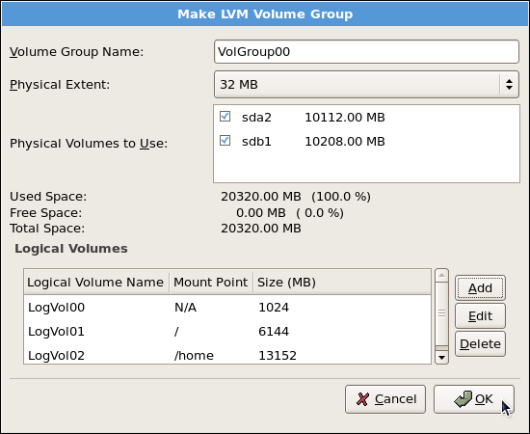
12. **Figure 11.11. Pending Logical Volumes**
13. Click **OK** to apply the volume group and all associated logical volumes.
14. The following figure shows the final manual configuration:
15. [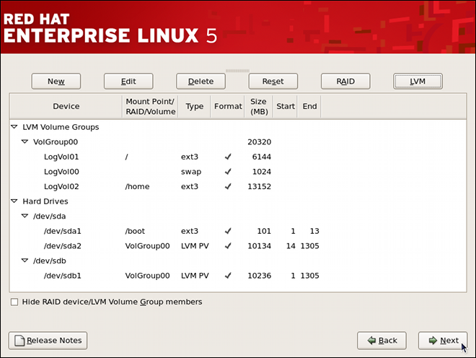](https://access.redhat.com/webassets/avalon/d/Red_Hat_Enterprise_Linux-5-Deployment_Guide-en-US/images/15ba1f756aabceb49a33929888d24c21/lvm-manual-done.png)
16. **Figure 11.12. Final Manual Configuration**

# USING THE LVM UTILITY SYSTEM-CONFIG-LVM

The LVM utility allows you to manage logical volumes within X windows or graphically. You can access the application by selecting from your menu panel **System** > **Administration** > **Logical Volume Management**. Alternatively you can start the Logical Volume Management utility by typing system-config-lvm from a terminal.

In the example used in this section, the following are the details for the volume group that was created during the installation:

/boot - (Ext3) file system. Displayed under 'Uninitialized Entities'. (DO NOT initialize this partition).

LogVol00 - (LVM) contains the (/) directory (312 extents).

LogVol02 - (LVM) contains the (/home) directory (128 extents).

LogVol03 - (LVM) swap (28 extents).

The logical volumes above were created in disk entity /dev/hda2 while /boot was created in /dev/hda1. The system also consists of 'Uninitialized Entities' which are illustrated in [Figure 11.17, “Uninitialized Entities”](https://access.redhat.com/documentation/en-us/red_hat_enterprise_linux/5/html/deployment_guide/s1-system-config-lvm#system-config-lvm-main10). The figure below illustrates the main window in the LVM utility. The logical and the physical views of the above configuration are illustrated below. The three logical volumes exist on the same physical volume (hda2).

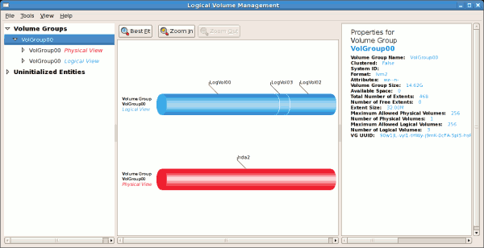

**Figure 11.13. Main LVM Window**

The figure below illustrates the physical view for the volume. In this window, you can select and remove a volume from the volume group or migrate extents from the volume to another volume group. Steps to migrate extents are discussed in [Figure 11.22, “Migrate Extents”](https://access.redhat.com/documentation/en-us/red_hat_enterprise_linux/5/html/deployment_guide/s1-system-config-lvm-migrate-extents#system-config-lvm-main36).

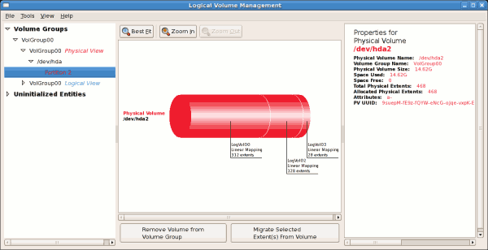

**Figure 11.14. Physical View Window**

The figure below illustrates the logical view for the selected volume group. The logical volume size is also indicated with the individual logical volume sizes illustrated.

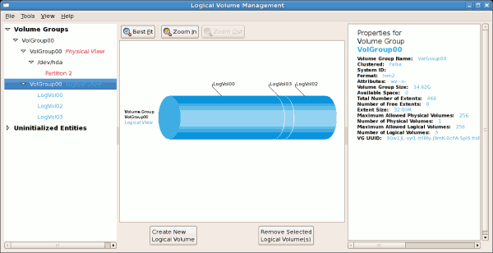

**Figure 11.15. Logical View Window**

On the left side column, you can select the individual logical volumes in the volume group to view more details about each. In this example the objective is to rename the logical volume name for 'LogVol03' to 'Swap'. To perform this operation select the respective logical volume and click on the **Edit Properties** button. This will display the Edit Logical Volume window from which you can modify the Logical volume name, size (in extents) and also use the remaining space available in a logical volume group. The figure below illustrates this.

Please note that this logical volume cannot be changed in size as there is currently no free space in the volume group. If there was remaining space, this option would be enabled (see [Figure 11.31, “Edit logical volume”](https://access.redhat.com/documentation/en-us/red_hat_enterprise_linux/5/html/deployment_guide/s1-system-config-lvm-editing-lv#system-config-lvm-main32)). Click on the **OK** button to save your changes (this will remount the volume). To cancel your changes click on the **Cancel** button. To revert to the last snapshot settings click on the **Revert** button. A snapshot can be created by clicking on the **Create Snapshot** button on the LVM utility window. If the selected logical volume is in use by the system (for example) the / (root) directory, this task will not be successful as the volume cannot be unmounted.

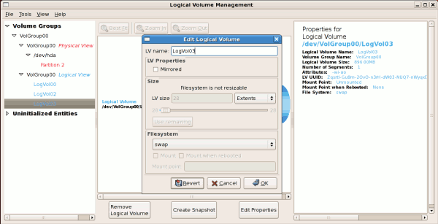

**Figure 11.16. Edit Logical Volume**

### 11.5.1. Utilizing uninitialized entities

'Uninitialized Entities' consist of unpartitioned space and non LVM file systems. In this example partitions 3, 4, 5, 6 and 7 were created during installation and some unpartitioned space was left on the hard disk. Please view each partition and ensure that you read the 'Properties for Disk Entity' on the right column of the window to ensure that you do not delete critical data. In this example partition 1 cannot be initialized as it is /boot. Uninitialized entities are illustrated below.

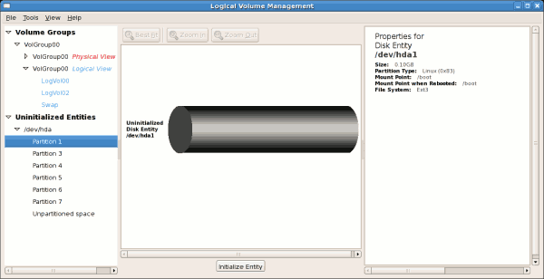

**Figure 11.17. Uninitialized Entities**

In this example, partition 3 will be initialized and added to an existing volume group. To initialize a partition or unpartioned space, select the partition and click on the **Initialize Entity** button. Once initialized, a volume will be listed in the 'Unallocated Volumes' list.

**ADDING UNALLOCATED VOLUMES TO A VOLUME GROUP**

Once initialized, a volume will be listed in the 'Unallocated Volumes' list. The figure below illustrates an unallocated partition (Partition 3). The respective buttons at the bottom of the window allow you to:

* create a new volume group,
* add the unallocated volume to an existing volume group,
* remove the volume from LVM.

To add the volume to an existing volume group, click on the **Add to Existing Volume Group** button.

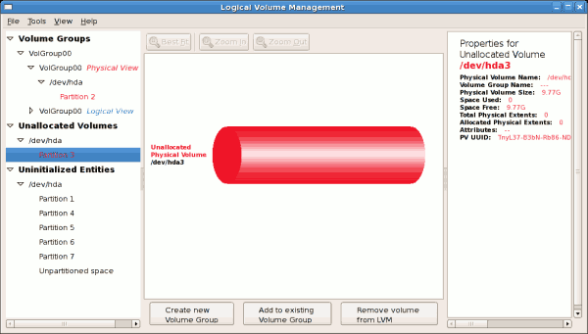

**Figure 11.18. Unallocated Volumes**

Clicking on the **Add to Existing Volume Group** button will display a pop up window listing the existing volume groups to which you can add the physical volume you are about to initialize. A volume group may span across one or more hard disks. In this example only one volume group exists as illustrated below.

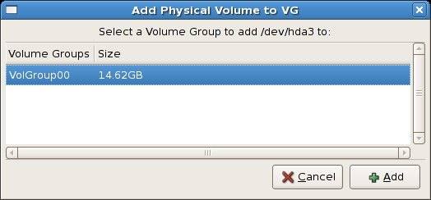

**Figure 11.19. Add physical volume to volume group**

Once added to an existing volume group the new logical volume is automatically added to the unused space of the selected volume group. You can use the unused space to:

* create a new logical volume (click on the **Create New Logical Volume(s)** button,
* select one of the existing logical volumes and increase the extents (see [Section 11.5.6, “Extending a volume group”](https://access.redhat.com/documentation/en-us/red_hat_enterprise_linux/5/html/deployment_guide/s1-system-config-lvm-ext-volumegrp)),
* select an existing logical volume and remove it from the volume group by clicking on the **Remove Selected Logical Volume(s)** button. Please note that you cannot select unused space to perform this operation.

The figure below illustrates the logical view of 'VolGroup00' after adding the new volume group.

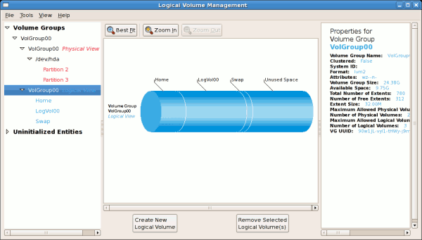

**Figure 11.20. Logical view of volume group**

In the figure below, the uninitialized entities (partitions 3, 5, 6 and 7) were added to 'VolGroup00'.

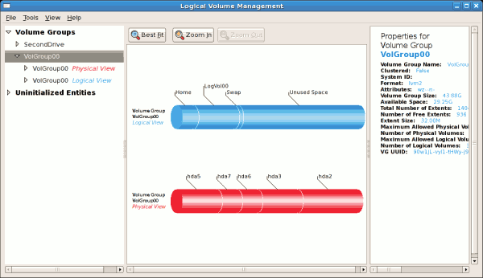

**Figure 11.21. Logical view of volume group**

**MIGRATING EXTENTS**

To migrate extents from a physical volume, select the volume and click on the **Migrate Selected Extent(s) From Volume** button. Please note that you need to have a sufficient number of free extents to migrate extents within a volume group. An error message will be displayed if you do not have a sufficient number of free extents. To resolve this problem, please extend your volume group (see [Section 11.5.6, “Extending a volume group”](https://access.redhat.com/documentation/en-us/red_hat_enterprise_linux/5/html/deployment_guide/s1-system-config-lvm-ext-volumegrp)). If a sufficient number of free extents is detected in the volume group, a pop up window will be displayed from which you can select the destination for the extents or automatically let LVM choose the physical volumes (PVs) to migrate them to. This is illustrated below.

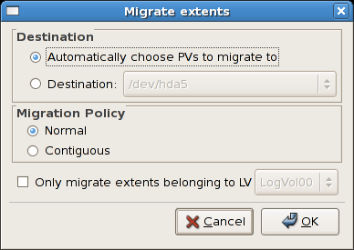

**Figure 11.22. Migrate Extents**

The figure below illustrates a migration of extents in progress. In this example, the extents were migrated to 'Partition 3'.

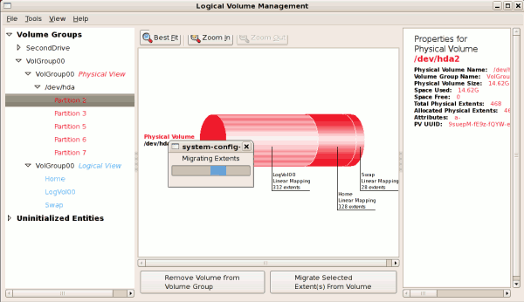

**Figure 11.23. Migrating extents in progress**

Once the extents have been migrated, unused space is left on the physical volume. The figure below illustrates the physical and logical view for the volume group. Please note that the extents of LogVol00 which were initially in hda2 are now in hda3. Migrating extents allows you to move logical volumes in case of hard disk upgrades or to manage your disk space better.

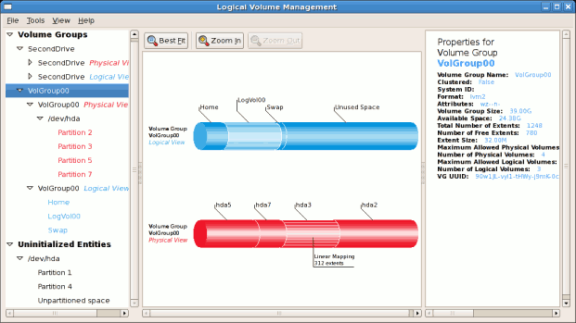

**Figure 11.24. Logical and physical view of volume group**

**ADDING A NEW HARD DISK USING LVM**

In this example, a new IDE hard disk was added. The figure below illustrates the details for the new hard disk. From the figure below, the disk is uninitialized and not mounted. To initialize a partition, click on the **Initialize Entity** button. For more details, see [Section 11.5.1, “Utilizing uninitialized entities”](https://access.redhat.com/documentation/en-us/red_hat_enterprise_linux/5/html/deployment_guide/s1-system-config-lvm#s1-system-config-lvm-uninitialized). Once initialized, LVM will add the new volume to the list of unallocated volumes as illustrated in [Figure 11.26, “Create new volume group”](https://access.redhat.com/documentation/en-us/red_hat_enterprise_linux/5/html/deployment_guide/s1-system-config-lvm-new-volumegrp#system-config-lvm-main17).

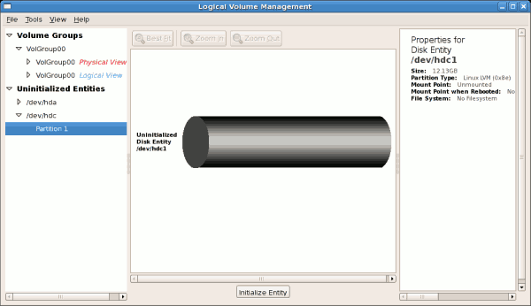

**Figure 11.25. Uninitialized hard disk**

**ADDING A NEW VOLUME GROUP**

Once initialized, LVM will add the new volume to the list of unallocated volumes where you can add it to an existing volume group or create a new volume group. You can also remove the volume from LVM. The volume if removed from LVM will be listed in the list of 'Uninitialized Entities' as illustrated in [Figure 11.25, “Uninitialized hard disk”](https://access.redhat.com/documentation/en-us/red_hat_enterprise_linux/5/html/deployment_guide/s1-system-config-lvm-new-hdd#system-config-lvm-main16). In this example, a new volume group was created as illustrated below.

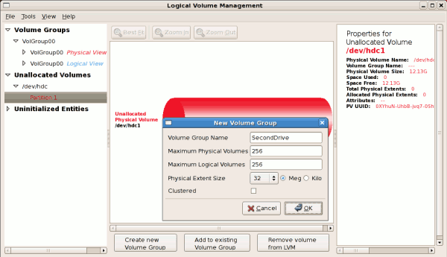

**Figure 11.26. Create new volume group**

Once created a new volume group will be displayed in the list of existing volume groups as illustrated below. The logical view will display the new volume group with unused space as no logical volumes have been created. To create a logical volume, select the volume group and click on the **Create New Logical Volume** button as illustrated below. Please select the extents you wish to use on the volume group. In this example, all the extents in the volume group were used to create the new logical volume.

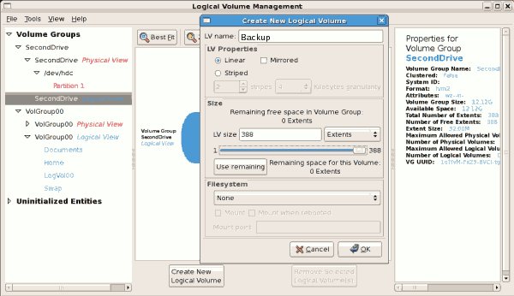

**Figure 11.27. Create new logical volume**

The figure below illustrates the physical view of the new volume group. The new logical volume named 'Backups' in this volume group is also listed.

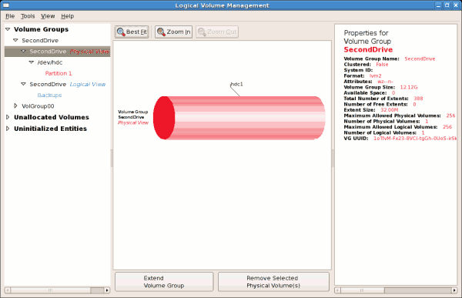

**Figure 11.28. Physical view of new volume group**

**EXTENDING A VOLUME GROUP**

In this example, the objective was to extend the new volume group to include an uninitialized entity (partition). This was to increase the size or number of extents for the volume group. To extend the volume group, click on the **Extend Volume Group** button. This will display the 'Extend Volume Group' window as illustrated below. On the 'Extend Volume Group' window, you can select disk entities (partitions) to add to the volume group. Please ensure that you check the contents of any 'Uninitialized Disk Entities' (partitions) to avoid deleting any critical data (see [Figure 11.25, “Uninitialized hard disk”](https://access.redhat.com/documentation/en-us/red_hat_enterprise_linux/5/html/deployment_guide/s1-system-config-lvm-new-hdd#system-config-lvm-main16)). In the example, the disk entity (partition) /dev/hda6 was selected as illustrated below.

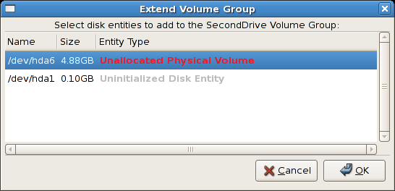

**Figure 11.29. Select disk entities**

Once added, the new volume will be added as 'Unused Space' in the volume group. The figure below illustrates the logical and physical view of the volume group after it was extended.

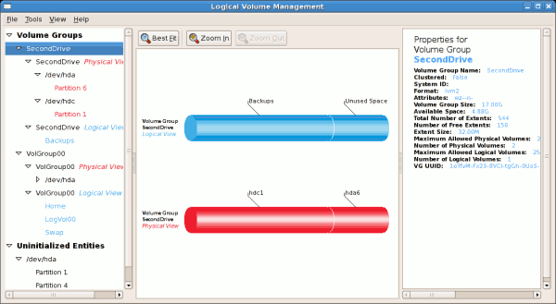

**Figure 11.30. Logical and physical view of an extended volume group**

The LVM utility allows you to select a logical volume in the volume group and modify its name, size and specify filesystem options. In this example, the logical volume named 'Backups" was extended onto the remaining space for the volume group.

Clicking on the **Edit Properties** button will display the 'Edit Logical Volume' popup window from which you can edit the properties of the logical volume. On this window, you can also mount the volume after making the changes and mount it when the system is rebooted. Please note that you should indicate the mount point. If the mount point you specify does not exist, a popup window will be displayed prompting you to create it. The 'Edit Logical Volume' window is illustrated below.

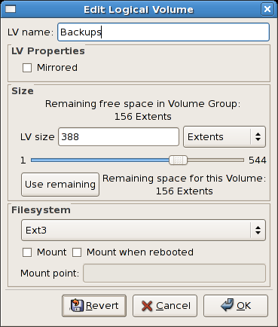

**Figure 11.31. Edit logical volume**

If you wish to mount the volume, select the 'Mount' checkbox indicating the preferred mount point. To mount the volume when the system is rebooted, select the 'Mount when rebooted' checkbox. In this example, the new volume will be mounted in /mnt/backups. This is illustrated in the figure below.

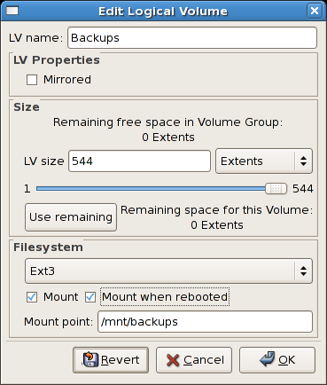

**Figure 11.32. Edit logical volume - specifying mount options**

The figure below illustrates the logical and physical view of the volume group after the logical volume was extended to the unused space. Please note in this example that the logical volume named 'Backups' spans across two hard disks. A volume can be striped across two or more physical devices using LVM.

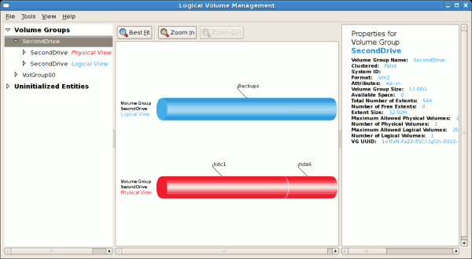

**Figure 11.33. Edit logical volume**

# ADDITIONAL RESOURCES

Use these sources to learn more about LVM.

### 11.6.1. Installed Documentation

* rpm -qd lvm2 — This command shows all the documentation available from the lvm package, including man pages.
* lvm help — This command shows all LVM commands available.

**USEFUL WEBSITES**

* <http://sources.redhat.com/lvm2> — LVM2 webpage, which contains an overview, link to the mailing lists, and more.
* <http://tldp.org/HOWTO/LVM-HOWTO/> — LVM HOWTO from the Linux Documentation Project.